Searching for data

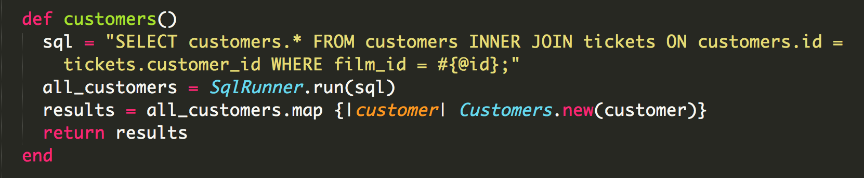

‘Customers’ method set up to retrieve customer information from the customers table. This method is run on a Film object and ties together the customer and film ID through the Tickets table to search for the correct information.



This is the output result from PRY after running the customers method on an object ‘film1’.

Sorting data



‘Customers’ method set up to retrieve customer information from the customers table. This method is run on a Film object and ties together the customer and film ID through the Tickets table to search for the correct information.



This is the output result from PRY after running the customers method on an object ‘film1’.